

Project Report

Bachelor in Computer Applications

Semester-II

Video Game Sales

By
Ashif Raza
2411021240056

Department of Computer Application
Alliance University
Chandapura – Anekal Main Road, Anekal
Bengaluru – 562 106

April 2025
1. Introduction

This project is based on the analysis of video game sales data from different regions of the world. The dataset contains information about thousands of video games, including their rank and sales figures in major markets such as North America, Europe, Japan, and other regions. It also includes the total global sales for each game. With over 16,000 entries, this dataset gives us a good opportunity to study the global video game industry and understand how games perform in different parts of the world.
Video games are a major part of modern entertainment. They are played by people of all ages across different platforms like PlayStation, Xbox, PC, and more. The gaming industry keeps growing every year, and understanding sales data can help us learn what kind of games are popular, where they sell the most, and how preferences change from region to region. For example, a game that is popular in North America might not sell as well in Japan, and vice versa.
In this project, I will use statistical methods and data visualization techniques to analyze the data. I will perform Univariate Analysis (studying one variable at a time), Bivariate Analysis (studying relationships between two variables), and Multivariate Analysis (studying more than two variables together) to find meaningful patterns in the data.
Objective
The main objective of this project is to understand and analyze video game sales across different regions. I want to explore:
Which region has the highest and lowest video game sales?
What is the average global sales per game?
How are sales distributed across regions?
Are there any noticeable patterns in global video game performance?

GitHub Link: https :-

import pandas as pd
data=pd.read_csv(r'C:\Users\ASUS\Downloads\vgsales.csv')
data
Rank Name Platform Year \
0 1 Wii Sports Wii 2006
1 2 Super Mario Bros. NES 1985
2 3 Mario Kart Wii Wii 2008
3 4 Wii Sports Resort Wii 2009
4 5 Pokemon Red/Pokemon Blue GB 1996
... ... ... ... ...
16593 16596 Woody Woodpecker in Crazy Castle 5 GBA 2002
16594 16597 Men in Black II: Alien Escape GC 2003
16595 16598 SCORE International Baja 1000: The Official Game PS2 2008
16596 16599 Know How 2 DS 2010
16597 16600 Spirits & Spells GBA 2003
Genre Publisher NA_Sales EU_Sales JP_Sales Other_Sales \
0 Sports Nintendo 41.49 29.02 3.77 8.46
1 Platform Nintendo 29.08 3.58 6.81 0.77
2 Racing Nintendo 15.85 12.88 3.79 3.31
3 Sports Nintendo 15.75 11.01 3.28 2.96
4 Role-Playing Nintendo 11.27 8.89 10.22 1.00
... ... ... ... ... ... ...
16593 Platform Kemco 0.01 0.00 0.00 0.00
16594 Shooter Infogrames 0.01 0.00 0.00 0.00
16595 Racing Activision 0.00 0.00 0.00 0.00
16596 Puzzle 7G//AMES 0.00 0.01 0.00 0.00
16597 Platform Wanadoo 0.01 0.00 0.00 0.00
Global_Sales
0 82.74
1 40.24
2 35.82
3 33.00
4 31.37
... ...
16593 0.01
16594 0.01
16595 0.01
16596 0.01
16597 0.01
[16598 rows x 11 columns]
data.describe
<bound method NDFrame.describe of Rank Name Platform Year \
0 1 Wii Sports Wii 2006
1 2 Super Mario Bros. NES 1985
2 3 Mario Kart Wii Wii 2008
3 4 Wii Sports Resort Wii 2009
4 5 Pokemon Red/Pokemon Blue GB 1996
... ... ... ... ...
16593 16596 Woody Woodpecker in Crazy Castle 5 GBA 2002
16594 16597 Men in Black II: Alien Escape GC 2003
16595 16598 SCORE International Baja 1000: The Official Game PS2 2008
16596 16599 Know How 2 DS 2010
16597 16600 Spirits & Spells GBA 2003
Genre Publisher NA_Sales EU_Sales JP_Sales Other_Sales \
0 Sports Nintendo 41.49 29.02 3.77 8.46
1 Platform Nintendo 29.08 3.58 6.81 0.77
2 Racing Nintendo 15.85 12.88 3.79 3.31
3 Sports Nintendo 15.75 11.01 3.28 2.96
4 Role-Playing Nintendo 11.27 8.89 10.22 1.00
... ... ... ... ... ... ...
16593 Platform Kemco 0.01 0.00 0.00 0.00
16594 Shooter Infogrames 0.01 0.00 0.00 0.00
16595 Racing Activision 0.00 0.00 0.00 0.00
16596 Puzzle 7G//AMES 0.00 0.01 0.00 0.00
16597 Platform Wanadoo 0.01 0.00 0.00 0.00
Global_Sales
0 82.74
1 40.24
2 35.82
3 33.00
4 31.37
... ...
16593 0.01
16594 0.01
16595 0.01
16596 0.01
16597 0.01
[16598 rows x 11 columns]>
data.describe()
Rank NA_Sales EU_Sales JP_Sales Other_Sales \
count 16598.000000 16598.000000 16598.000000 16598.000000 16598.000000
mean 8300.605254 0.263768 0.145958 0.077801 0.048070
std 4791.853933 0.816594 0.505120 0.309294 0.188588
min 1.000000 0.000000 0.000000 0.000000 0.000000
25% 4151.250000 0.000000 0.000000 0.000000 0.000000
50% 8300.500000 0.080000 0.020000 0.000000 0.010000
75% 12449.750000 0.240000 0.110000 0.040000 0.040000
max 16600.000000 41.490000 29.020000 10.220000 10.570000
Global_Sales
count 16596.000000
mean 0.537498
std 1.555113
min 0.010000
25% 0.060000
50% 0.170000
75% 0.470000
max 82.740000
data.info()
<class 'pandas.core.frame.DataFrame'>
RangeIndex: 16598 entries, 0 to 16597
Data columns (total 11 columns):
# Column Non-Null Count Dtype
--- ------ -------------- -----
0 Rank 16598 non-null int64
1 Name 16598 non-null object
2 Platform 16598 non-null object
3 Year 16327 non-null object
4 Genre 16598 non-null object
5 Publisher 16540 non-null object
6 NA_Sales 16598 non-null float64
7 EU_Sales 16598 non-null float64
8 JP_Sales 16598 non-null float64
9 Other_Sales 16598 non-null float64
10 Global_Sales 16596 non-null float64
dtypes: float64(5), int64(1), object(5)
memory usage: 1.4+ MB
data.tail(5)
Rank Name Platform Year \
16593 16596 Woody Woodpecker in Crazy Castle 5 GBA 2002
16594 16597 Men in Black II: Alien Escape GC 2003
16595 16598 SCORE International Baja 1000: The Official Game PS2 2008
16596 16599 Know How 2 DS 2010
16597 16600 Spirits & Spells GBA 2003
Genre Publisher NA_Sales EU_Sales JP_Sales Other_Sales \
16593 Platform Kemco 0.01 0.00 0.0 0.0
16594 Shooter Infogrames 0.01 0.00 0.0 0.0
16595 Racing Activision 0.00 0.00 0.0 0.0
16596 Puzzle 7G//AMES 0.00 0.01 0.0 0.0
16597 Platform Wanadoo 0.01 0.00 0.0 0.0
Global_Sales
16593 0.01
16594 0.01
16595 0.01
16596 0.01
16597 0.01
#Histogram
sns.histplot(data['Global_Sales'])
<Axes: xlabel='Global_Sales', ylabel='Count'>
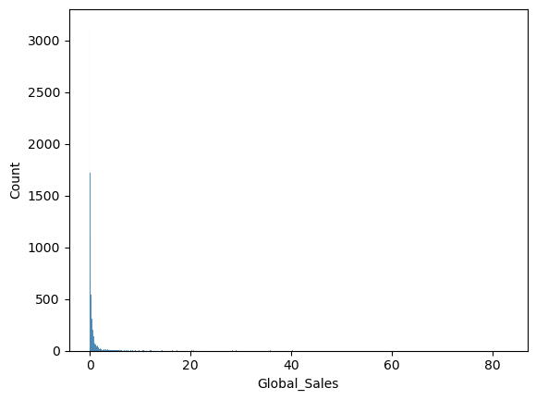
#UNIVARIATE ANALYSIS
import pandas as pd
import seaborn as sns
data = pd.read_csv(r"C:\Users\ASUS\Downloads\vgsales.csv")
print(data.head(5))
Rank Name Platform Year Genre Publisher \
0 1 Wii Sports Wii 2006 Sports Nintendo
1 2 Super Mario Bros. NES 1985 Platform Nintendo
2 3 Mario Kart Wii Wii 2008 Racing Nintendo
3 4 Wii Sports Resort Wii 2009 Sports Nintendo
4 5 Pokemon Red/Pokemon Blue GB 1996 Role-Playing Nintendo
NA_Sales EU_Sales JP_Sales Other_Sales Global_Sales
0 41.49 29.02 3.77 8.46 82.74
1 29.08 3.58 6.81 0.77 40.24
2 15.85 12.88 3.79 3.31 35.82
3 15.75 11.01 3.28 2.96 33.00
4 11.27 8.89 10.22 1.00 31.37
#Bargraph
sns.countplot(x=data['Genre'])
<Axes: xlabel='Genre', ylabel='count'>
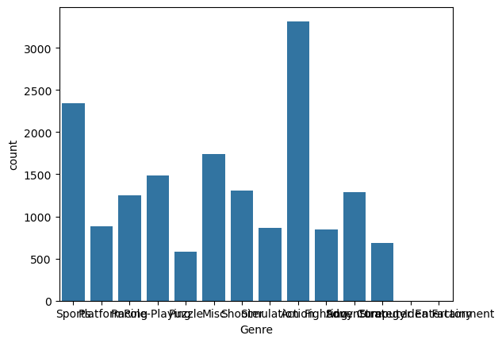
#Bargraph
sns.countplot(x=data['Publisher'])
<Axes: xlabel='Publisher', ylabel='count'>
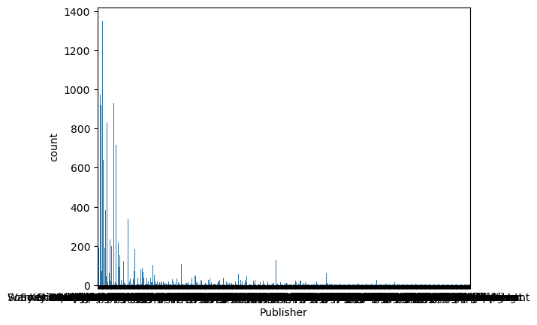
# Pie chart to show the distribution of 'Publisher' in the dataset
import matplotlib.pyplot as plt
x = data['Publisher'].value_counts()
plt.pie(x.values, labels=x.index, autopct='%1.1f%%')
plt.show()
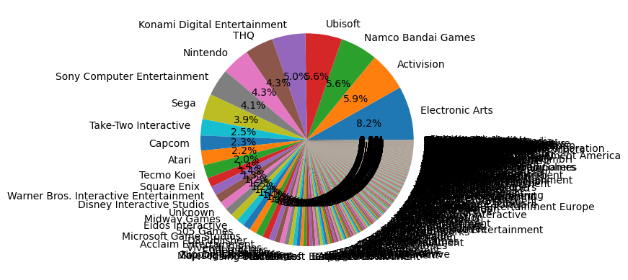
# BIVARIATE ANALYSIS
# Categorical vs numerical
import matplotlib.pyplot as plt
import seaborn as sns
plt.figure(figsize=(15, 5))
sns.barplot(x=data['Genre'], y=data['Global_Sales'])
plt.xticks(rotation=90)
plt.show()
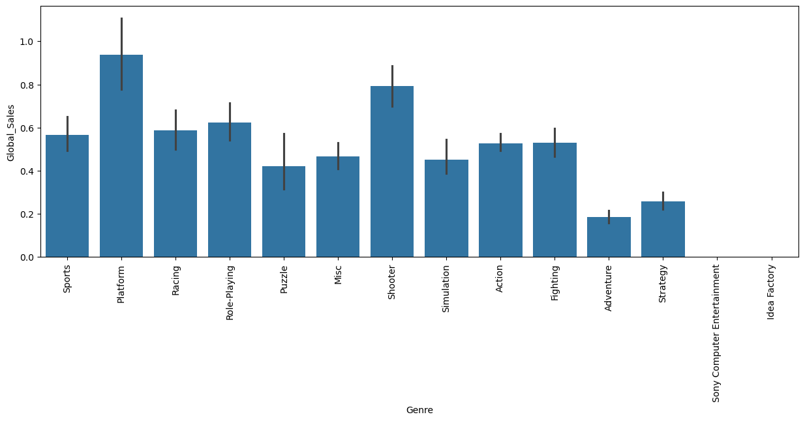
# Numerical v/s Numerical
sns.scatterplot(x=data['NA_Sales'], y=data['EU_Sales'])
<Axes: xlabel='NA_Sales', ylabel='EU_Sales'>
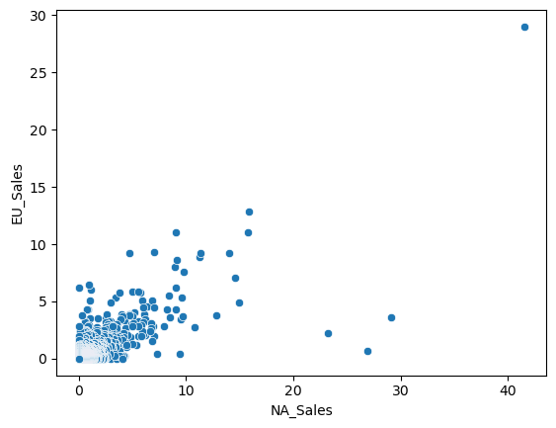
# Categorical v/s Categorical
sns.countplot(x='Genre', hue='Platform', data=data)
<Axes: xlabel='Genre', ylabel='count'>
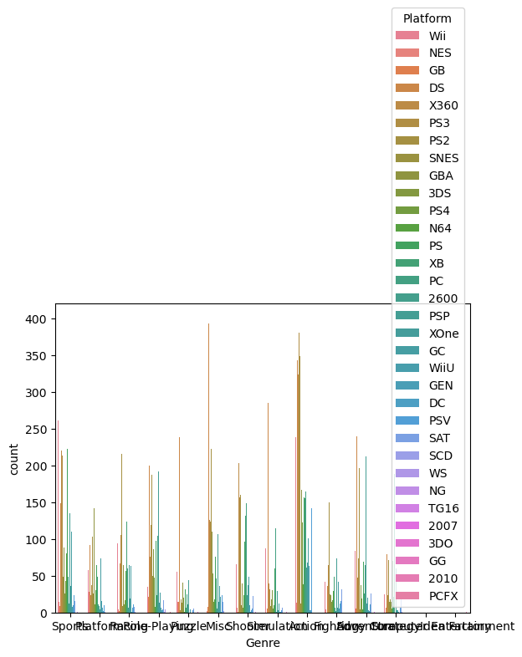
# MULTIVARIATE ANALYSIS
# principal component analysis
from sklearn import datasets, decomposition
from sklearn.preprocessing import LabelEncoder
# Drop rows with NaN values in the selected columns
data_cleaned = data.dropna(subset=['NA_Sales', 'EU_Sales', 'JP_Sales', 'Other_Sales', 'Global_Sales'])
X = data_cleaned[['NA_Sales', 'EU_Sales', 'JP_Sales', 'Other_Sales', 'Global_Sales']]
y = LabelEncoder().fit_transform(data_cleaned['Platform'])
pca = decomposition.PCA(n_components=2)
X = pca.fit_transform(X)
sns.scatterplot(x=X[:, 0], y=X[:, 1], hue=y)
<Axes: >
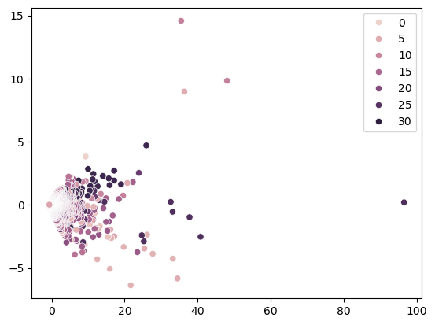
# Heat map
import seaborn as sns
sns.heatmap(data[['NA_Sales', 'EU_Sales', 'JP_Sales', 'Other_Sales', 'Global_Sales']].corr(), annot=True)
<Axes: >
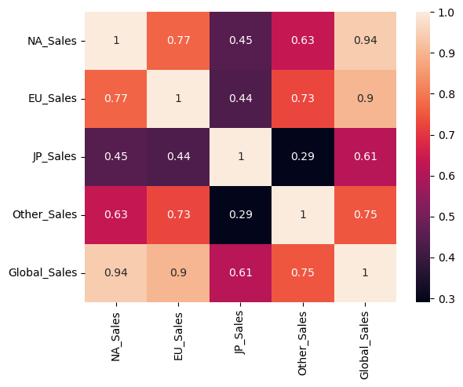

6. Conclusion
In this project, I analyzed video game sales data from different regions around the world. The dataset helped me understand how video games perform in markets such as North America, Europe, Japan, and other parts of the world. By using Univariate, Bivariate, and Multivariate Analysis, I was able to observe patterns, trends, and differences in regional preferences and total global sales.
From the analysis, it was clear that North America generally leads in video game sales, followed by Europe, while Japan and Other regions have comparatively lower sales figures. This shows that different regions have different levels of market size and interest in video games. I also found that many games have very low or no sales in certain regions, which suggests that game popularity and demand can vary a lot depending on location.
Through visualizations and statistics, I was also able to explore the average global sales per game, find outliers, and understand how sales are spread across the dataset. The analysis shows that while a few games achieve very high sales, most games have relatively low sales numbers. This highlights the competitive nature of the video game industry, where only a small number of titles become top-sellers.
Overall, this project gave me valuable insights into the video game industry and its global performance. It also helped me improve my understanding of data analysis methods and how to apply them to real-world datasets. This kind of analysis can be helpful for game developers, publishers, and marketers to understand market trends and make better decisions based on data.

